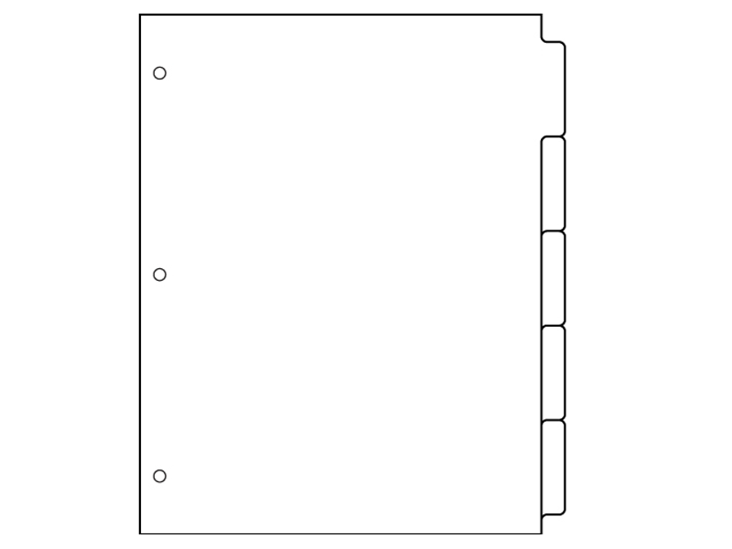

WH Business Contains:

* Daily Agenda
* Passes
* Syllabus
* This document

Core Work Contains:

* Unit Problem Notebook Worksheets

Returned Work Contains:

* Any work that has been graded and returned. This may include homework, tests, quizzes, projects, and essays.

Class work Contains:

* Table of Contents with dates
* All class work, in chronological order with pages numbered

Returned Work

How to Organize your

WHP: World History Binder

WH Business

Class work

UP Notebook